Cyber Security Interest Group

Lab sheet

**Preparing Kali Linux Virtual Machine**

**(Note: Unauthorized Hacking is Illegal!!)**

**About this Lab:**

Kali Linux has many preinstalled software tools for penetration-testing and digital forensics. This lab is going to guide you to prepare a working Kali Linux virtual machine and introduce some basics about it.

**Before the Lab:**

* Download Kali Linux disc image from: <https://www.kali.org/downloads/>
  + Kali Linux 64 Bit or Kali Linux 32 Bit Images depends on your system support
* Download and install Hypervisor such as VMware Workstation Player from: https://www.vmware.com/products/workstation-player/workstation-player-evaluation.html

**Let’s do it:**

1. Run VMware Workstation Player (Hypervisor)

What is Hypervisor?

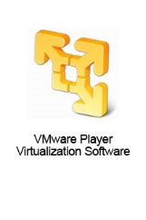 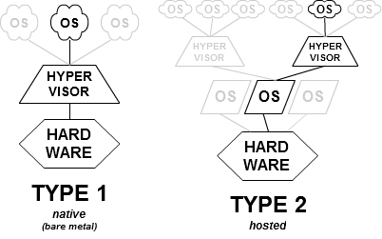

Let’s use it

1. Create New Virtual Machine

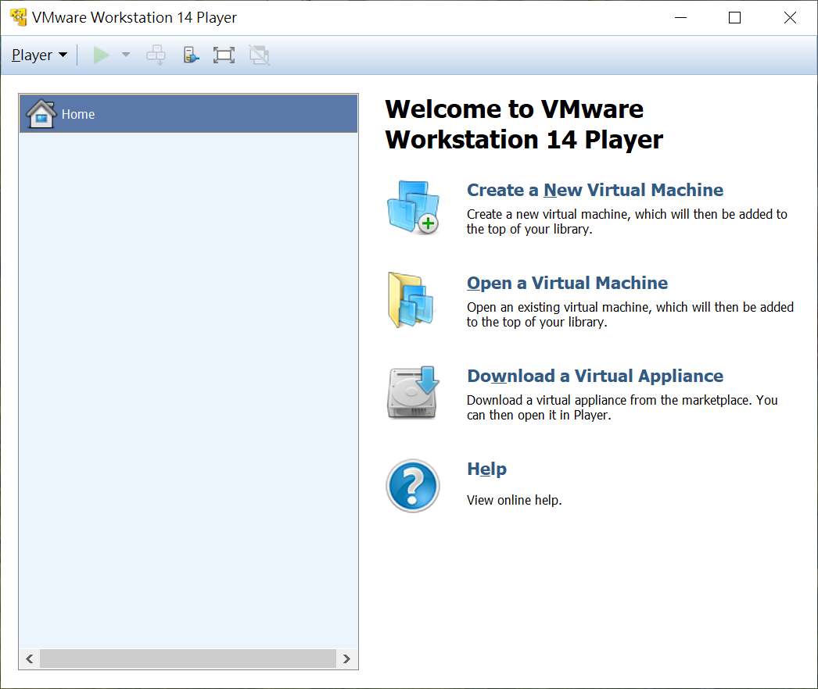

1. Check ‘Installer disc image file (iso):’ and browse kali Linux disk image. Click Next ->

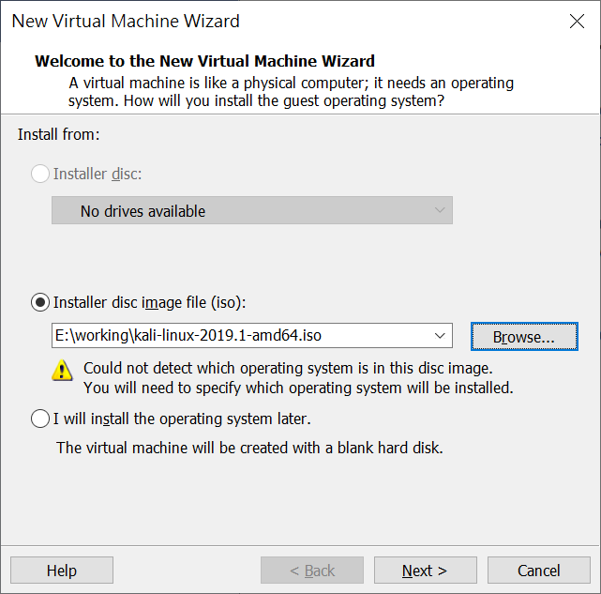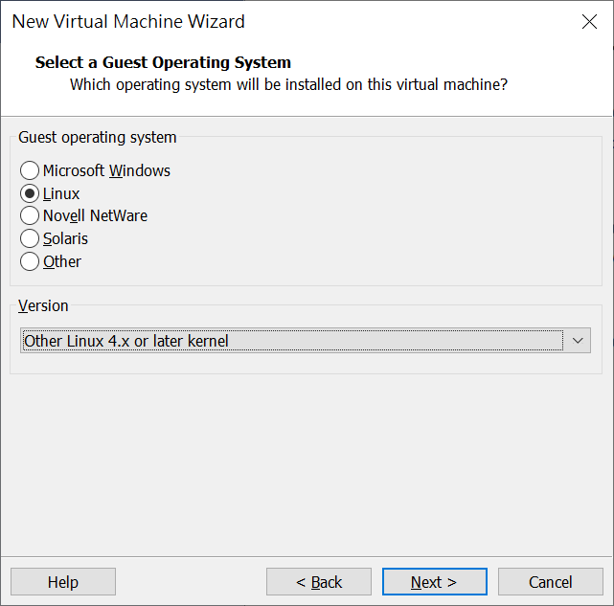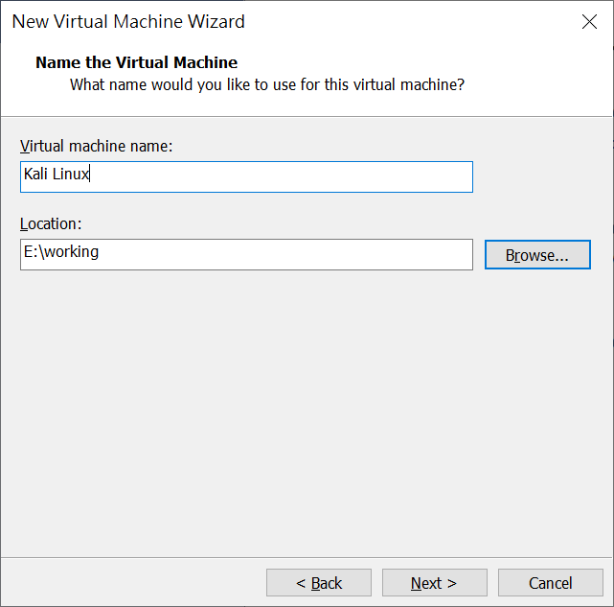

1. Select Linux in the list of ‘Guest operating system’ and select ‘Other Linux 4.x or later kernel’ in the list of ‘Version’. Click Next ->

# Select “Other Linux 4.x or later kernel 64 bit” if you are installing 64 bits Kali Linux

1. Name your virtual machine in the field of “Virtual machine name”. Click Next ->

# You can also change the location of your Virtual machine

1. Give 20.0GB for the ‘Maximum disk size (GB)’ since Kali Linux need 20 GB disk space for the installation. Store virtual disk as a single file or multiple files options are up to you. Click Next ->
2. Click ‘Customize Hardware…’. Give at least 1024MB memory for this virtual machine. Click ‘Close’. Your setting looks like the screenshot below. Click ‘Finish’.

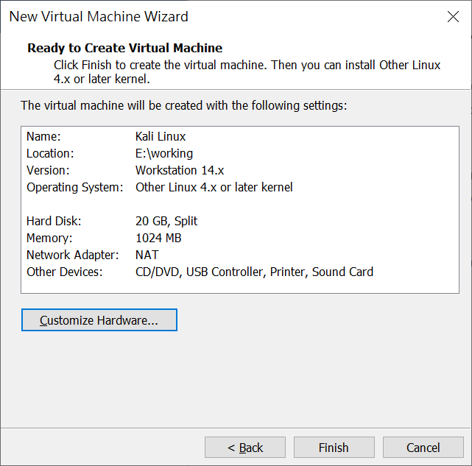 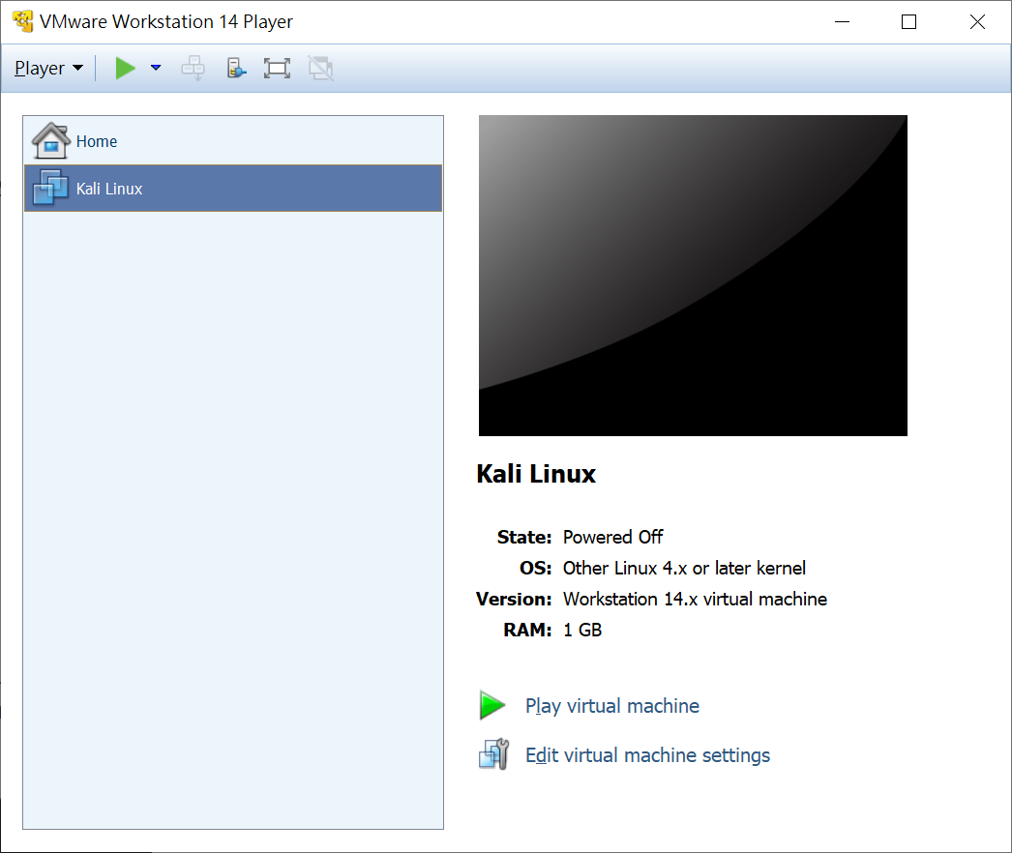

1. Let’s ‘Play virtual machine’
2. You should see this menu if you create virtual machine correctly. Navigate to ‘Install’ using the arrow key of your keyboard and hit ‘Enter’.

# Make sure you are focusing this virtual machine windows. A left click of mouse to the **display area** of the virtual machine will do.

**You can always escape the control of virtual machine by pressing ‘Alt+ctrl’ !!!**

(All your mouse and keyboard inputs were sent to the virtual machine when focusing)

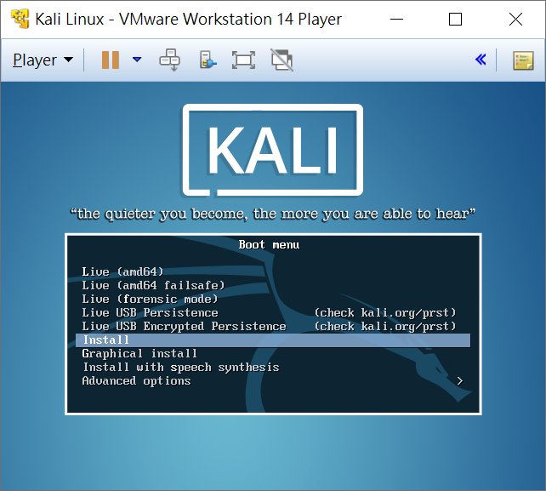

Display Area

There are different modes for Kali Linux

But we want to install it

Let’s go with ‘Install’

1. Kali Linux installer will start and prepare things for you.

# Note that the mouse might not work during the installation stage.

Keep calm and use keyboard!

**# Try ‘Esc’ if you want to go back to previous step during the installation**

1. Select language. Just hit ‘Enter’.
2. Select Location. Navigate to ‘Hong Kong’ and hit ‘Enter’.
3. Keymap to use. Just hit ‘Enter’.
4. Enter the hostname of your virtual machine. You might want to avoid suspicion from others by using other names. In this example, we used “kali” as our hostname. Hit ‘Enter’.
5. Just hit ‘Enter’ key if you don’t have domain name.
6. Setup password for root user. Strong password is always recommended! Hit ‘Enter’ when done.
7. Enter the root password again. Hit ‘Enter’.
8. Partition disks#1. Select ‘Guided – Use entire disk’. Hit ‘Enter’.
9. Partition disks#2. Select the disk. Hit ‘Enter’.
10. Partition disks#3. Select ‘All files in one partition…’. Hit ‘Enter’.
11. Partition disks#4. Select ‘Finish partitioning and write changes to disk’. Hit ‘Enter’.
12. Partition disks#5. Hit ‘Tab’ to navigate the highlight to ‘Yes’. Hit ‘Enter’.
13. Installing the system. . . sit back and relax. . .
14. Use a network mirror? ‘Yes’. Hit ‘Enter’.
15. HTTP Proxy information. We don’t need proxy, just leave it blank and hit ‘Enter’.
16. Install the GRUB boot loader to the master boot record? ‘Yes’. Hit ‘Enter’.
17. Device for boot loader installation. Select ‘/dev/sda’ and hit ‘Enter’.
18. Installation complete! ‘Continue’. Hit ‘Enter’.
19. The installer will terminate itself and reboot the virtual machine. You should see the screen below after the reboot. After 5 seconds, it enters Kali Linux automatically.

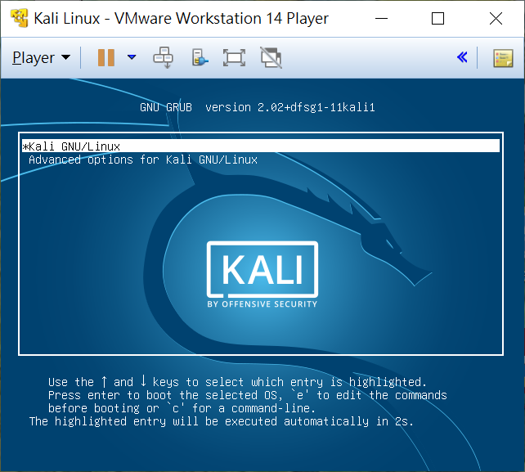 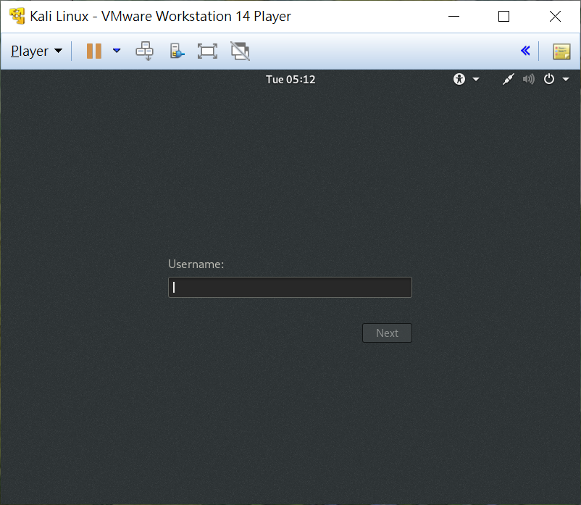

1. Login as ‘root’ with the password you configured during installation.
2. Your are ready to do some interesting things.

